COB Led Blinder 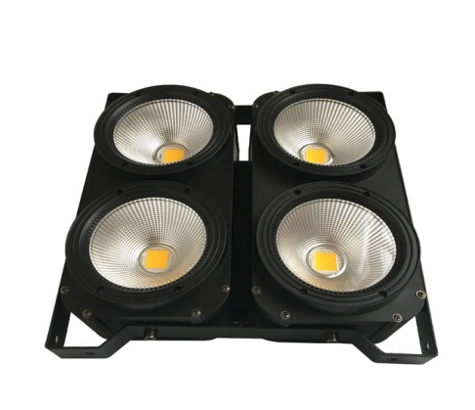
- Master Dimmer 0-255
- Strobe 0-off
1-255 – slow fast
- Effects 0-50 - off
51-100 - effect 1
101-200 - effect 2
201-255 - effect 3

- Speed Effects 0-255
- 1 lamp – warm lights 0-255
- 1 lamp – cold lights 0-255
- 2 lamp – warm lights 0-255
- 2 lamp – cold lights 0-255
- 3 lamp – warm lights 0-255
- 3 lamp – cold lights 0-255
- 4 lamp – warm lights 0-255
- 4 lamp – cold lights 0-255

